January 2019

A NEW COMMANDMENT, A NEW BEGINNING
By Pastor Rob Benardo

After Judas had left, Jesus said, “Now the Son of Man's glory is revealed; now God's glory is revealed through him. And if God's glory is revealed through him, then God will reveal the glory of the Son of Man in Him, and he will do so at once. My children, I shall not be with you very much longer. You will look for me; but I tell you now what I told the Jewish authorities, ‘You cannot go where I am going.’ And now I give you a new commandment: love one another. As I have loved you, so you must love one another. If you have love for one another, then everyone will know that you are my disciples” John 13:31-35 (Good News Translation).

Jesus here is still in the upper room giving instruction to His disciples. Judas has said “no” to Jesus’ final appeal and Christ is left with the eleven. And so here, couched between the desertion of Judas and the prediction of Peter’s denial soon to come is this amazing challenge to the disciples to love in a “new” way. Certainly, this is not “new” to them, in the sense that they have never heard it before, but it was new in sense that they had not done it. No doubt Jesus had just given “love” a new depth of meaning by washing their feet and soon He would show love to the ultimate degree by going to the cross to die.

Christ did not just ask them to love as the world loves one another, but set Himself as the standard of love for His disciples. “As I have loved you”, you are to love one another. No doubt, this message was to apply to His disciples down through the ages of time. No doubt it would apply to us in this last period of time, right down to His coming in glory. And so, as we begin 2019, maybe God has a new command for us. It seems today that even professional courtesy and common respect is lacking, in our country and sometimes in our church. As one friend of mine has put it, “It seems that some people have taken off their kindness filters.” You see, it is one thing to disagree, but quite another to do so in an unprofessional and unchristian way.

Christ’s standard, however, is far, far above the low ebb of ethics and kindness that we have sunken to today. He calls us to love each other “as He has loved us”. And what is the measure of His love? It is to be willing to give up even life eternal for those that disagree and even hate you and despitefully use you. For He died for us while we yet sinners and even enemies of His. Now you may be thinking, “That is a tough one pastor.” Actually, it is not a tough one, but impossibility unless Christ comes in to our hearts and plants His divine love there. And yet this miracle will take place, the only questions are “with who” and “when”. So, why not now, and why not YOU (and me)? “By this shall all men know that you are my disciples if you love one another?”

A troubled world is waiting to see something better than what they have around them. They are waiting to see something better than what man can produce. They are waiting to see the love of God lived out in real time, and when they see it, many will give up on themselves and every worldly thing and follow Christ all the way. Its 2019 and God is waiting, too. He is waiting for His bride, His church to put on His righteousness so the world and the onlooking universe can see. Let’s make 2019 the year that God waits no longer. Let’s make it the year that God turns Battle Creek upside down with His love. It starts with one “new” person at a time. May God start with you?

PAST, PRESENT, FUTURE
by Lorrie Rietman

Over the holidays, we spent time at my parents’ home. They live in the rural rolling hills of New York State. Soon after we arrived it was a beautiful day, so I went for a walk through the fields which surround their home. As I walked out on top of a hill, I paused to look around. From that location I could see the farmhouse in which my grandmother grew up and met my grandfather when he worked as a farm hand for her father. Down the way from that farmhouse stands the house in which my grandparents lived for over 50 years. That home is chock full of memories of my childhood, as just up the road about two miles is the spot where I grew up.

When I was 18, my parents moved to the home where we were visiting that day. As I stood there taking in the views, I reflected on all the memories from these locations. It brought melancholy over me, because the farmhouse of my grandmother is not the same. My grandparents’ house is no longer occupied by them. My childhood home was torn down. And also, in my view from the hill was a cemetery just across the road from my grandparents’ house. Laid to rest in that cemetery is much of my mother’s side of the family including my grandfather. The brevity of life seemed encompassed in that view from the hill. Lives lived and loved and worked for will all end up in that cemetery but for the 2nd coming of Jesus.

As I finished my walk, I went back to my family determined to enjoy the day and create memories for my children. As a new year is upon us, let us not lose perspective of how fleeting and fragile life is and may we make the most of it, for our present concerns and for eternity. “So, teach us to number our days, that we may gain a heart of wisdom.” Psalm 90:12 ‬‬‬‬‬‬

PATHFINDER CLUB REPORT
By Brad and Tracey Hall, Directors of the Battle Creek Pioneers Pathfinder Club

In December the pathfinders got to enjoy "flying high" time at District 5 Extreme Air Sports in Lansing. They played dodge ball and basketball, jumped on trampolines, attempted an air obstacle course and much more while landing safely in foam filled pits.

Lots of smiles and laughing filled the evening. What a great way to celebrate all the hard work the Pathfinders did in November. It's also nice to see our kids have fun together and be active!

THIRD ANNUAL RECEPTION & RECOGNITION
Joanne Rector, Hospitality Hub

On Sabbath evening, December 1, 2018, our Tabernacle family attended a special event in the Seminar Room to welcome and honor our newest members who have joined the Tabernacle during the past year through baptism, profession of faith, or transfer of membership. Following this group photo, all attendees were invited to link hands in a circular fashion and sing together “Blest Be the Tie That Binds.” We fellowshipped with our newest members while enjoying light refreshments in the Dining Hall. It brings us great joy to welcome and get acquainted with these new members

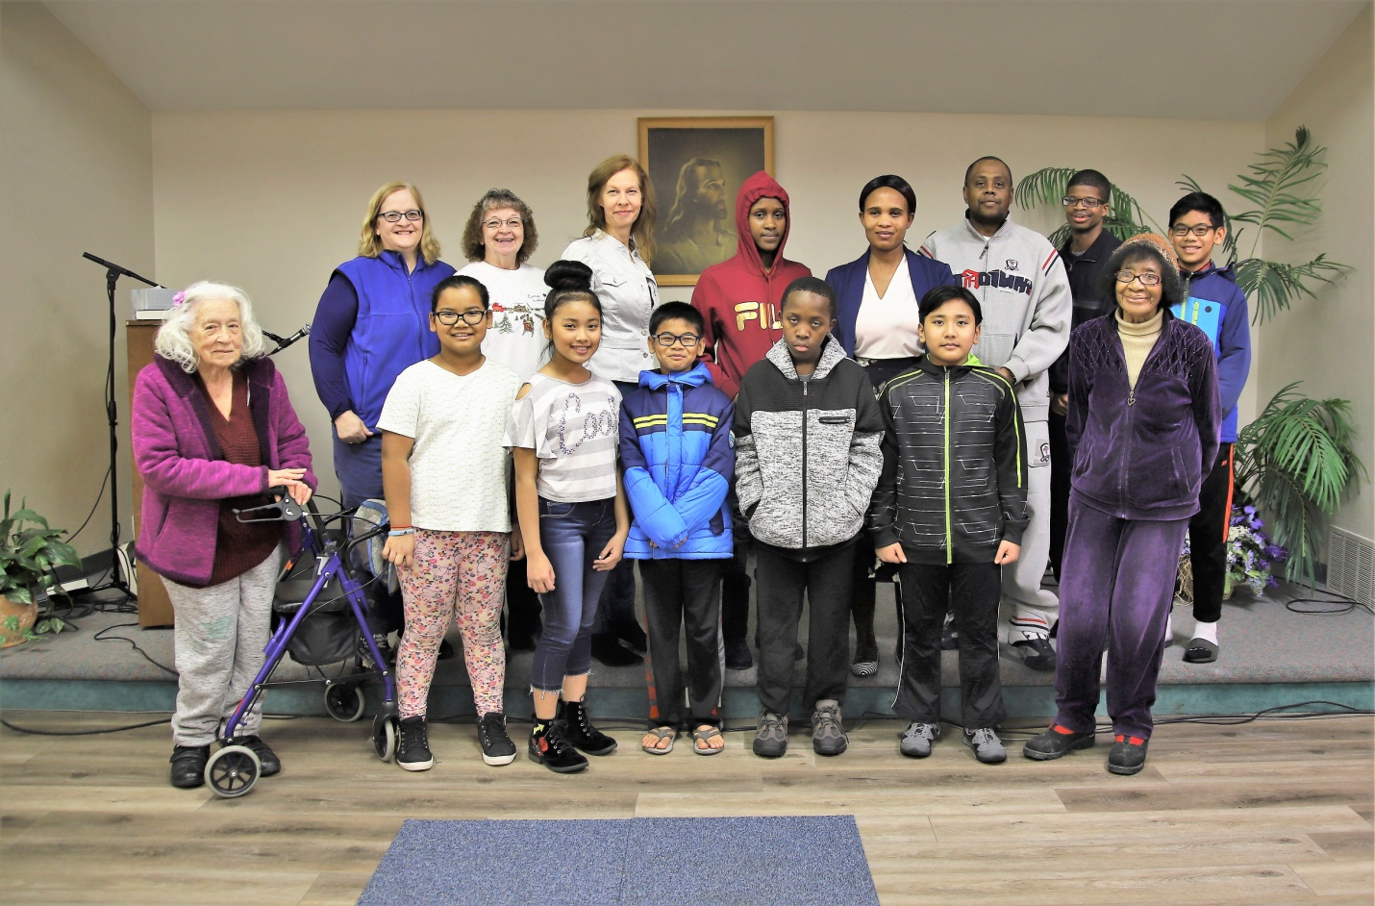

UPCOMING EVENTS & ANNOUNCEMENTS

CONCERT SERIES: Our free concert series starts on January 12 at 7:00 p.m. with Laura Williams. Laura’s love of singing began as a freshman in high school. God has since led her to full time ministry in music. She now travels around the world giving concerts, providing music for various events, speaking and telling people about the amazing things God can do for us, all when we put our full trust in Him. Come and invite your family and friends for some wonderful spiritual music.

LADIES TEA: January 7 at 1:00 p.m. in the Dining Room. We will play board games and hot drinks will be supplied. Please contact Pam Metcalf for more information.

BIBLE STUDY: Tuesdays, January 8, 22 & 29 at 7:00 p.m. in the Seminar Room. We will continue our study of the most precious message the Lord sent to His people. It is a very powerful message designed by Him for His people giving the assurance of salvation and the necessary power to prepare them for the time of trouble, which is brewing in the world today. From Jerry Finneman

BIBLE MARKING: Friday, January 25 from 7:00 to 8:00 p.m. (Junior Classroom); come and have fun transforming your Bible into a witnessing tool, which also makes it easier to study your Bible with others.

WINSOME WITNESSING: Sabbaths, January 12 & 26, from 2:00 to 3:00 p.m. in the Seminar Room. In this class, you will learn how to share your faith with others without “beating people up” with the truth, but rather sharing the truth in a winsome way.

